# Difference between

Varchar, varchar2, nvarchar

Varchar  
 Non Unicode  
 take 2000 length  
 Stored data in fixed size

Nvarchar  
 Unicode(can store any language character)

Take 4000 length

Store data in variable size

Varchar2

Non Unicode

Take 4000 length

Store data in variable size

## Where and having

Where – filter records in table

Having – filter records in group by clause result

## Union and Union All

Union – it merges two table by skipping common rows, Remove Duplicate value

Union All – – it merges two table with all common and non-common rows. does not remove Duplicate values  
  
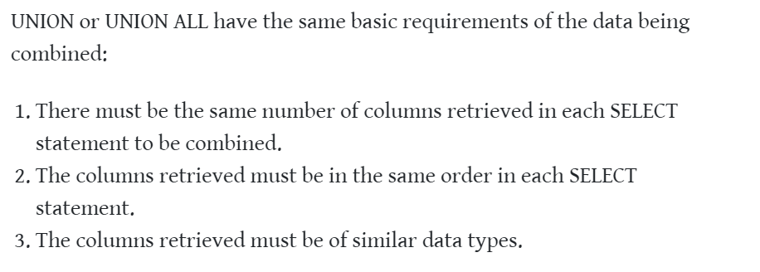

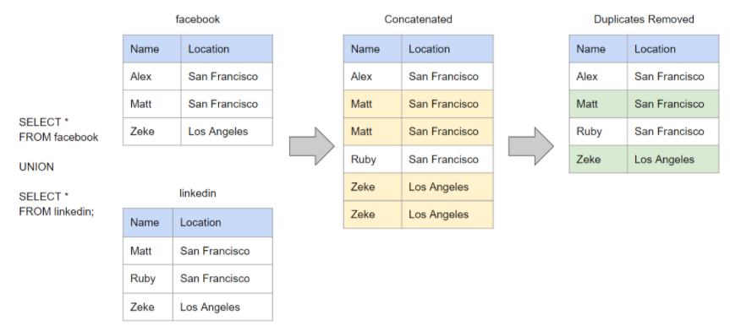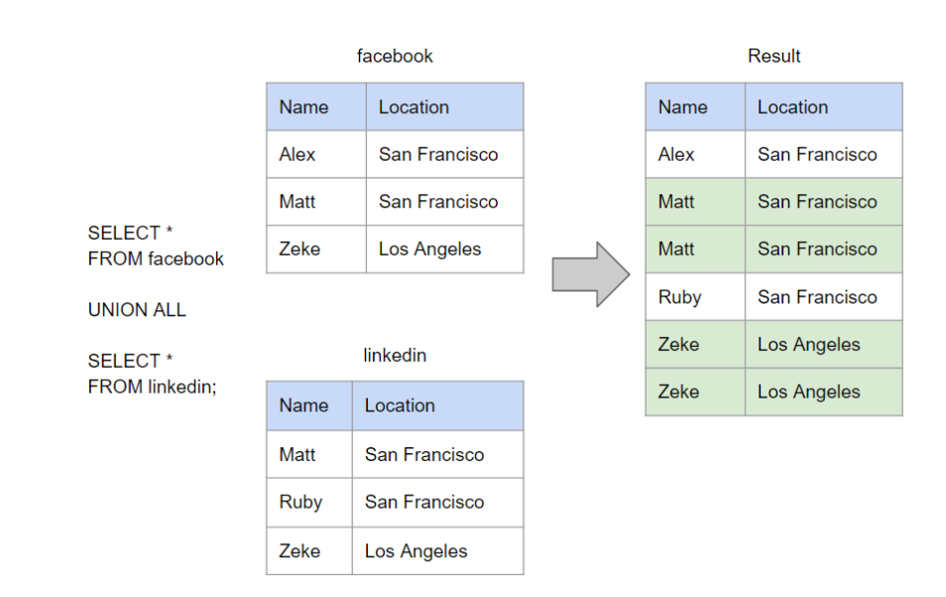

## Join , Nested Sub Query , Co-related Query

**Nested Subquery**   
inner query run first and then outer query

Outer query works on result set of inner queries

**Corelated Query**

First outer query will execute

Every single record of outer query will be matched with all records of inner query

### Question

– select details of employee, department wise , whose salary is greater than average salary of that department   
  
select *   
from Employee inner join department   
on Employee.DptID = Department.dptID  
group by Emp DptID   
Having emp.salary > avg(salary)

**Join**Cross Join + condition

## IN and Exist

Exist   
The EXISTS operator is used to test for the existence of any record in a subquery.

The EXISTS operator returns TRUE if the subquery returns one or more records.

IN  
The IN operator allows you to specify multiple values in a WHERE clause.

The IN operator is a shorthand for multiple OR conditions.

# Scenario Based Question

## 2.1 How to find the employee with second MAX Salary using a SQL query?

Select max(salary) from employee  
where salary not in (Select max(salary) from employee)

## 2.2 find details of employee having second max salary

**Using nested Subquery**

Select * from employee   
where salary = (Select max(salary) from employee  
where salary not in (Select max(salary) from employee)

## )

**Using Joins**

# Joins

https://www.techmixing.com/2019/04/sql-joins-tricky-interview-questions.html

## 